UART-Based Servo Motor Control on Wokwi
STM32 NUCLEO + Arduino Framework

Course | Embedded Systems Programming
Platform | STM32 NUCLEO-C031C6 / STM32 NUCLEO compatible board on Wokwi
Development Environment | Wokwi + Arduino Framework
Main Topic | UART Command Processing and PWM Servo Control
Student Name / ID | ____________________________________________

Lab Overview
In this lab, students build a virtual STM32 servo circuit on Wokwi and complete an Arduino program that receives UART commands from the Serial Monitor to rotate a servo motor to specific angles.

1. Learning Outcomes
- Build a simple STM32 servo circuit on Wokwi.
- Use Serial.begin(), Serial.available(), and Serial.read() for UART communication.
- Use the Servo library to control a servo motor through a PWM-capable pin.
- Map UART characters to servo angles using switch-case.
- Validate and limit the servo angle between 0 and 180 degrees.

2. Required Components
Component | Quantity | Purpose
STM32 NUCLEO board in Wokwi | 1 | Microcontroller platform
Servo motor | 1 | Actuator controlled by PWM signal
Jumper wires | 3 | Connect signal, VCC, and GND
Wokwi Serial Monitor | 1 | Send UART commands to the board

3. Circuit Wiring Guide
Servo Wire | STM32 / Wokwi Pin | Description
Orange / Signal | PC7 | PWM control signal from STM32 to servo
Red / VCC | 5V | Servo power supply
Brown / Black / GND | GND | Common ground
Reference circuit in Wokwi:
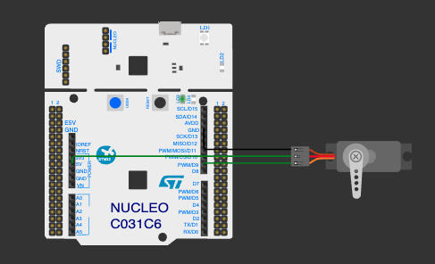
Figure 1. STM32 NUCLEO servo wiring on Wokwi: PC7 is connected to the servo signal pin, with 5V and GND connected to the servo power pins.
Important Wiring Note
The servo must share the same GND with the STM32 board. If the signal wire is connected to PC7 but the ground is not common, the servo may not respond correctly.

4. Functional Requirements
UART Command | Required Servo Action | Expected Serial Output
0 | Move to 0 degrees | Servo angle = 0 degree
1 | Move to 45 degrees | Servo angle = 45 degree
2 | Move to 90 degrees | Servo angle = 90 degree
3 | Move to 135 degrees | Servo angle = 135 degree
4 | Move to 180 degrees | Servo angle = 180 degree
a / A | Decrease angle by 10 degrees | Servo angle = current - 10
d / D | Increase angle by 10 degrees | Servo angle = current + 10
c / C | Return servo to center | Servo angle = 90 degree

5. Wokwi Practice Procedure
UART in Wokwi
No external UART module is required. In this simulation, the Wokwi Serial Monitor is used as the UART terminal to send characters to the STM32 board.
- Open Wokwi and create a new STM32 NUCLEO project using the Arduino framework.
- Add one servo motor to the project.
- Connect the servo signal wire to PC7, VCC to 5V, and GND to GND.
- Copy the starter code in Section 6 into main.cpp or sketch.ino.
- Complete all blanks marked with __________ or TODO.
- Start the simulation and open the Serial Monitor.
- Set the baud rate to 115200.
- Send commands 0, 1, 2, 3, 4, a, d, and c. Observe servo motion and Serial Monitor output.
- Take a screenshot of your working circuit and paste it into your lab report.

6. Starter Code - Fill in the Blanks
Complete the missing parts. Do not change the required command behavior.
#include <Arduino.h>
#include <Servo.h>
#define SERVO_PIN ____________ // PWM pin connected to servo signal
Servo myServo;
int angle = ____________; // Initial angle
void setServoAngle(int newAngle) {
if (newAngle < ____________) newAngle = ____________;
if (newAngle > ____________) newAngle = ____________;
angle = newAngle;
myServo.____________(angle);
Serial.print("Servo angle = ");
Serial.print(angle);
Serial.println(" degree");
}
void setup() {
Serial.begin(____________);
myServo.____________(SERVO_PIN);
setServoAngle(angle);
Serial.println("STM32 Servo UART Control Ready");
Serial.println("Send: 0,1,2,3,4,a,d,c");
Serial.println("0=0deg, 1=45deg, 2=90deg, 3=135deg, 4=180deg");
Serial.println("a=-10deg, d=+10deg, c=center");
}
void loop() {
if (Serial.____________() > 0) {
char cmd = Serial.____________();
if (cmd == '\n' || cmd == '\r') {
return;
}
Serial.print("Received: ");
Serial.println(cmd);
switch (cmd) {
case '0':
setServoAngle(____________);
break;
case '1':
setServoAngle(____________);
break;
case '2':
setServoAngle(____________);
break;
case '3':
setServoAngle(____________);
break;
case '4':
setServoAngle(____________);
break;
case 'a':
case 'A':
setServoAngle(angle - ____________);
break;
case 'd':
case 'D':
setServoAngle(angle + ____________);
break;
case 'c':
case 'C':
setServoAngle(____________);
break;
default:
Serial.println("Invalid command. Use 0,1,2,3,4,a,d,c");
break;
}
}
}

7. Command Cheat Sheet
Command / Syntax | Category | Purpose | Example
#include <Arduino.h> | Library | Enable Arduino core functions | pinMode(), Serial
#include <Servo.h> | Library | Enable servo control | Servo myServo;
#define SERVO_PIN PC7 | Pin definition | Name the servo signal pin | myServo.attach(SERVO_PIN);
Servo myServo; | Object | Create a servo object | myServo.write(90);
Serial.begin(115200); | UART | Start serial communication | Baud rate = 115200
Serial.available() | UART | Check whether data is available | if (Serial.available() > 0)
Serial.read() | UART | Read one received character | char cmd = Serial.read();
myServo.attach(pin); | Servo | Attach servo to a pin | myServo.attach(PC7);
myServo.write(angle); | Servo | Move servo to target angle | myServo.write(180);
switch(cmd) | Control logic | Select action based on command | case '0':
break; | Control logic | Exit current case | break;
return; | Control logic | Skip the rest of loop iteration | Ignore newline characters


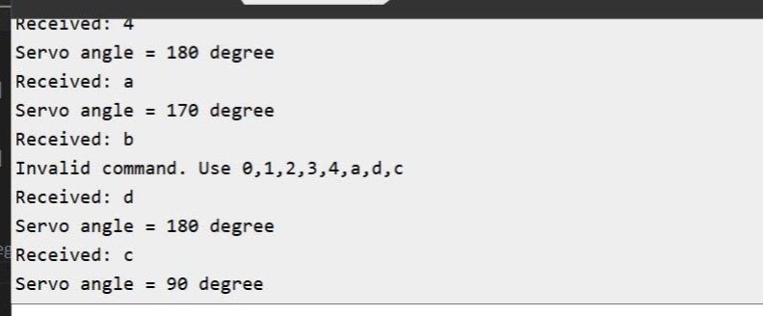

8. Review Questions
- Why must Serial.begin(115200) be called in setup()? UART (Universal Asynchronous Receiver/Transmitter) is an asynchronous communication method, meaning there is no shared clock wire between the sender and receiver. For data to be transferred correctly, both ends must be configured with the same settings, the most critical being the baud rate (transmission speed). Calling this initialization at the start of the program (in setup or main) ensures the hardware is ready to communicate at the correct speed before any data is sent.
- What is the function of Serial.available()? In serial communication, this function (equivalent to readable() in the Mbed API) is used to check if there are characters ready to be read from the receive buffer. It allows the program to verify if data has arrived before attempting to process it, preventing the CPU from trying to read empty or "junk" data.
- What is the difference between Serial.available() and Serial.read()?
  - available() (or readable()): This is a status check. It returns a value indicating if data is present in the buffer but does not remove or retrieve that data.
  - read() (or getc()): This is a retrieval operation. It actually pulls a character out of the data stream so the program can use it. In practice, you typically check available() in an if statement and then call read() to get the actual character.
- Why do we need to ignore newline characters \n and \r? In the ASCII character-encoding scheme, \n (newline) and \r (carriage return) are non-printing control characters. Terminal software on a computer often automatically appends these characters to the end of a typed string to mark the end of a line. If your program is looking for a specific command (like a single letter to move a motor), these hidden characters can be misinterpreted as invalid data or cause errors in your logic.
- Why should the servo angle be limited between 0 and 180 degrees? The position of a micro servo motor is controlled by the duty cycle of a PWM (Pulse Width Modulation) signal sent to its signal pin. Standard servos are mechanically designed to operate within a specific range, typically 0 to 180 degrees, which corresponds to specific pulse widths (e.g., between 1.25ms and 1.75ms). Attempting to drive the servo beyond these mechanical limits can cause physical stress, high current draw, or permanent damage to the motor's internal gears.

9. MainCode
#include <Arduino.h>
#include <Servo.h>

#define SERVO_PIN PC7 // PWM pin connected to servo signal [cite: 13, 48]
Servo myServo; // Create a servo object
int angle = 90; // Initial angle set to center (90 degrees) [cite: 18]

// Function to set and validate the servo angle
void setServoAngle(int newAngle) {
// Validate and limit the servo angle between 0 and 180 degrees [cite: 9]
if (newAngle < 0) newAngle = 0;
if (newAngle > 180) newAngle = 180;

angle = newAngle;
myServo.write(angle); // Move servo to target angle

Serial.print("Servo angle = ");
Serial.print(angle);
Serial.println(" degree");
}

void setup() {
Serial.begin(115200); // Start serial communication at 115200 baud rate
myServo.attach(SERVO_PIN); // Attach servo to the defined pin
setServoAngle(angle);

Serial.println("STM32 Servo UART Control Ready");
Serial.println("Send: 0,1,2,3,4,a,d,c");
Serial.println("0=0deg, 1=45deg, 2=90deg, 3=135deg, 4=180deg");
Serial.println("a=-10deg, d=+10deg, c=center");
}

void loop() {
// Check whether data is available in the UART buffer
if (Serial.available() > 0) {
char cmd = Serial.read(); // Read one received character

// Ignore newline and carriage return characters
if (cmd == '\n' || cmd == '\r') {
return;
}

Serial.print("Received: ");
Serial.println(cmd);

// Select action based on the received UART command
switch (cmd) {
case '0':
setServoAngle(0); // Move to 0 degrees [cite: 18]
break;
case '1':
setServoAngle(45); // Move to 45 degrees [cite: 18]
break;
case '2':
setServoAngle(90); // Move to 90 degrees [cite: 18]
break;
case '3':
setServoAngle(135); // Move to 135 degrees [cite: 18]
break;
case '4':
setServoAngle(180); // Move to 180 degrees [cite: 18]
break;
case 'a':
case 'A':
setServoAngle(angle - 10); // Decrease angle by 10 degrees [cite: 18]
break;
case 'd':
case 'D':
setServoAngle(angle + 10); // Increase angle by 10 degrees [cite: 18]
break;
case 'c':
case 'C':
setServoAngle(90); // Return servo to center (90 degrees) [cite: 18]
break;
default:
Serial.println("Invalid command. Use 0,1,2,3,4,a,d,c");
break;
}
}
}

